EXPERIMENT:11: Create a simple cloud software application for online super market using any Cloud Service Provider to demonstrate SaaS with the template of customer name, address, phone, email, items, quantity etc. with the item classification form.

STEP:1: CREATE A APPLICATION FORM FOR THE CUSTOMER DETAILS.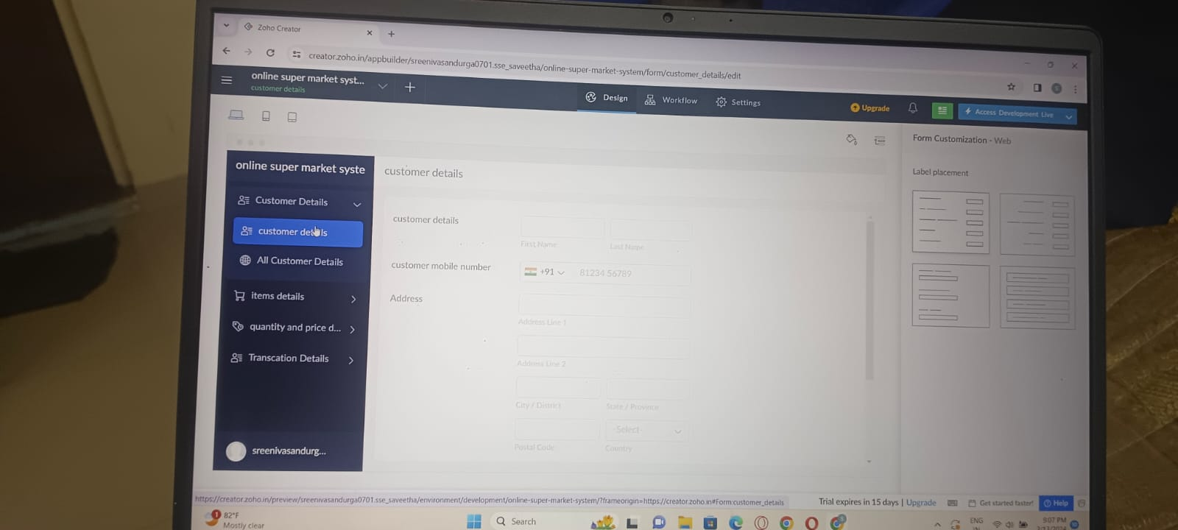

STEP:2 CREATE A APPLICATION FORM FOR THE ITEM DETAILS.

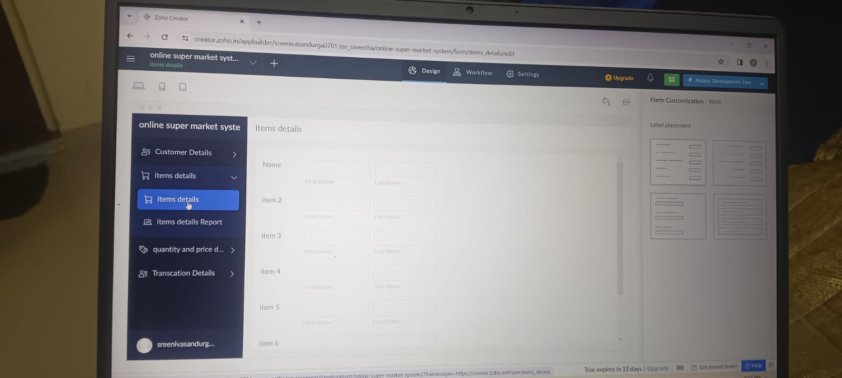

STEP:3: CREATE A APPLICATION FORM FOR THE PRICE AND THE QUANTITY DETAILS.

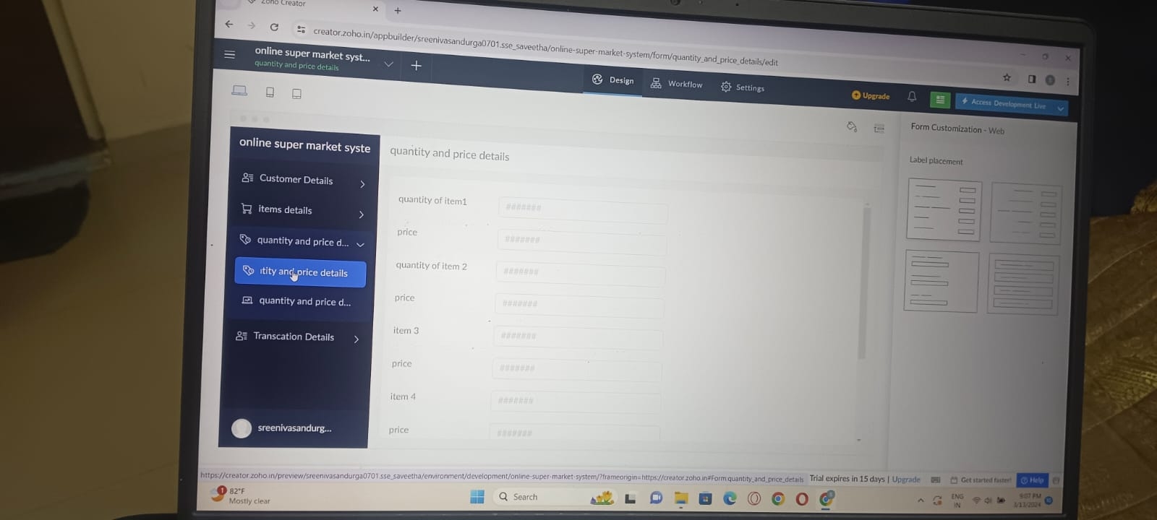

STEP:4:CREATE A APPLICATION FORM FOR THE TRANSACTION DETAILS.

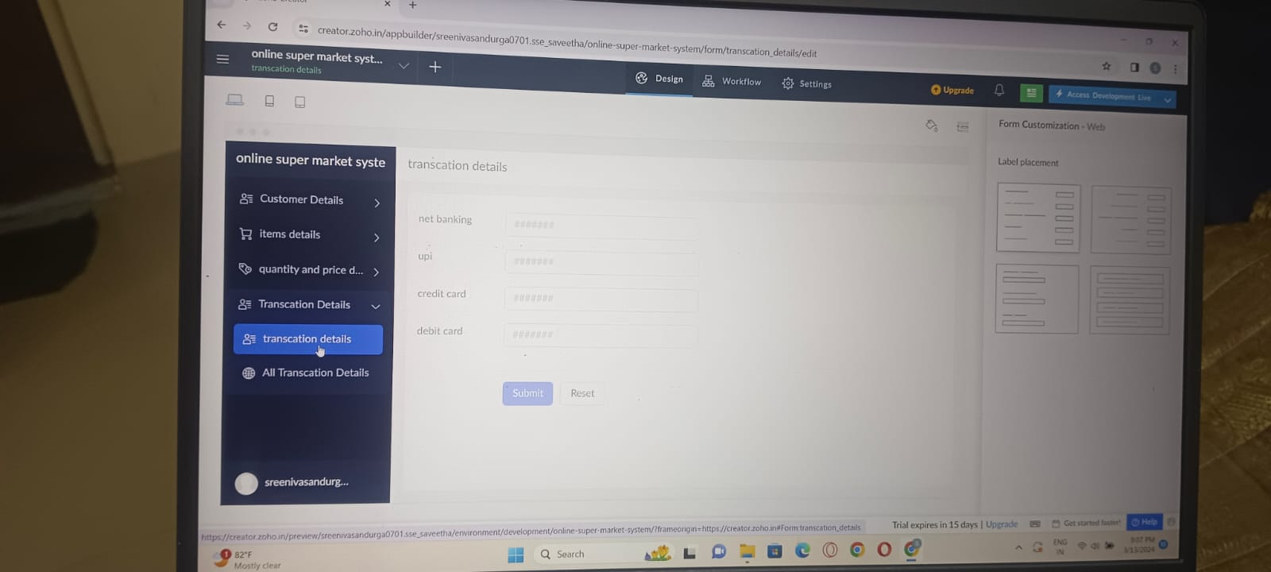

STEP:5: CREATE A APPLICATION FORM FOR THE SUPER MARKET RESULT.

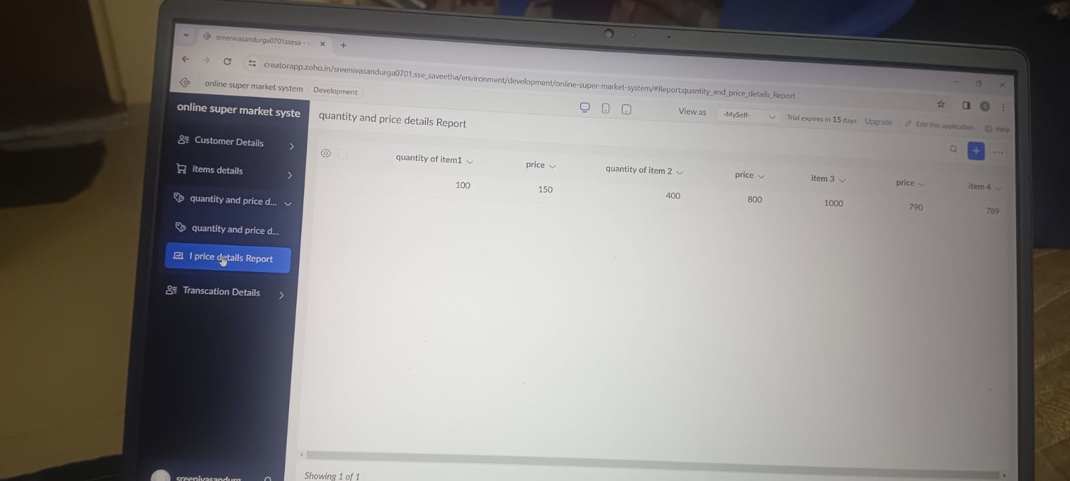

RESULT: THUS,THE PROGRAM FOR THE SUPER MARKET HAS BEEN EXCEUTED SUUCCESSFULLY.